Chapter 17, Problem 4.

Find the Fourier series expansion of the backward sawtooth waveform of
Fig. 17.48. Obtain the amplitude and phase spectra.

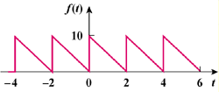

Figure 17.48
For Prob. 17.4.

